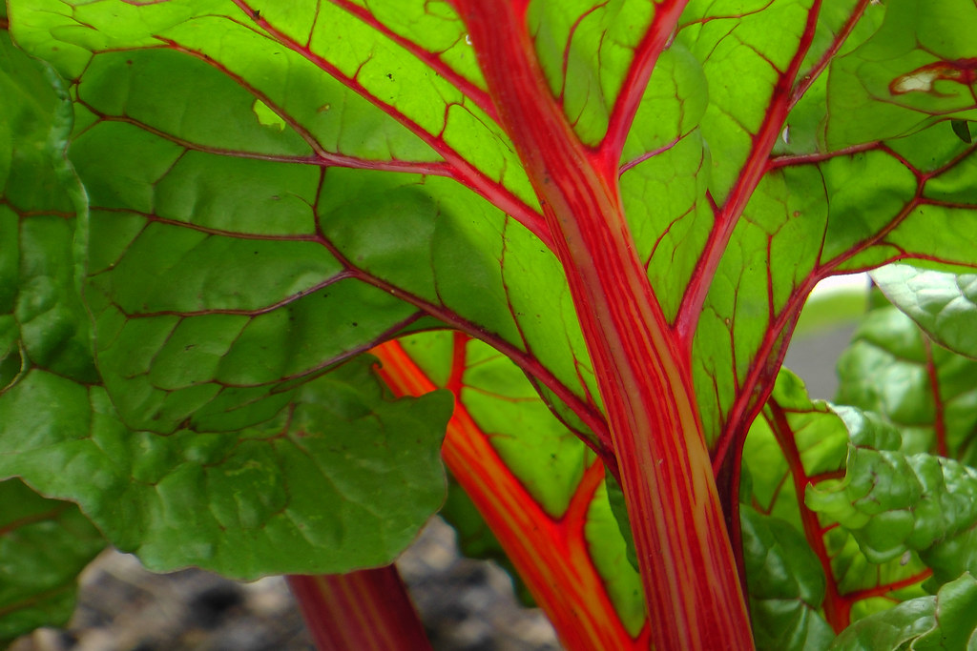
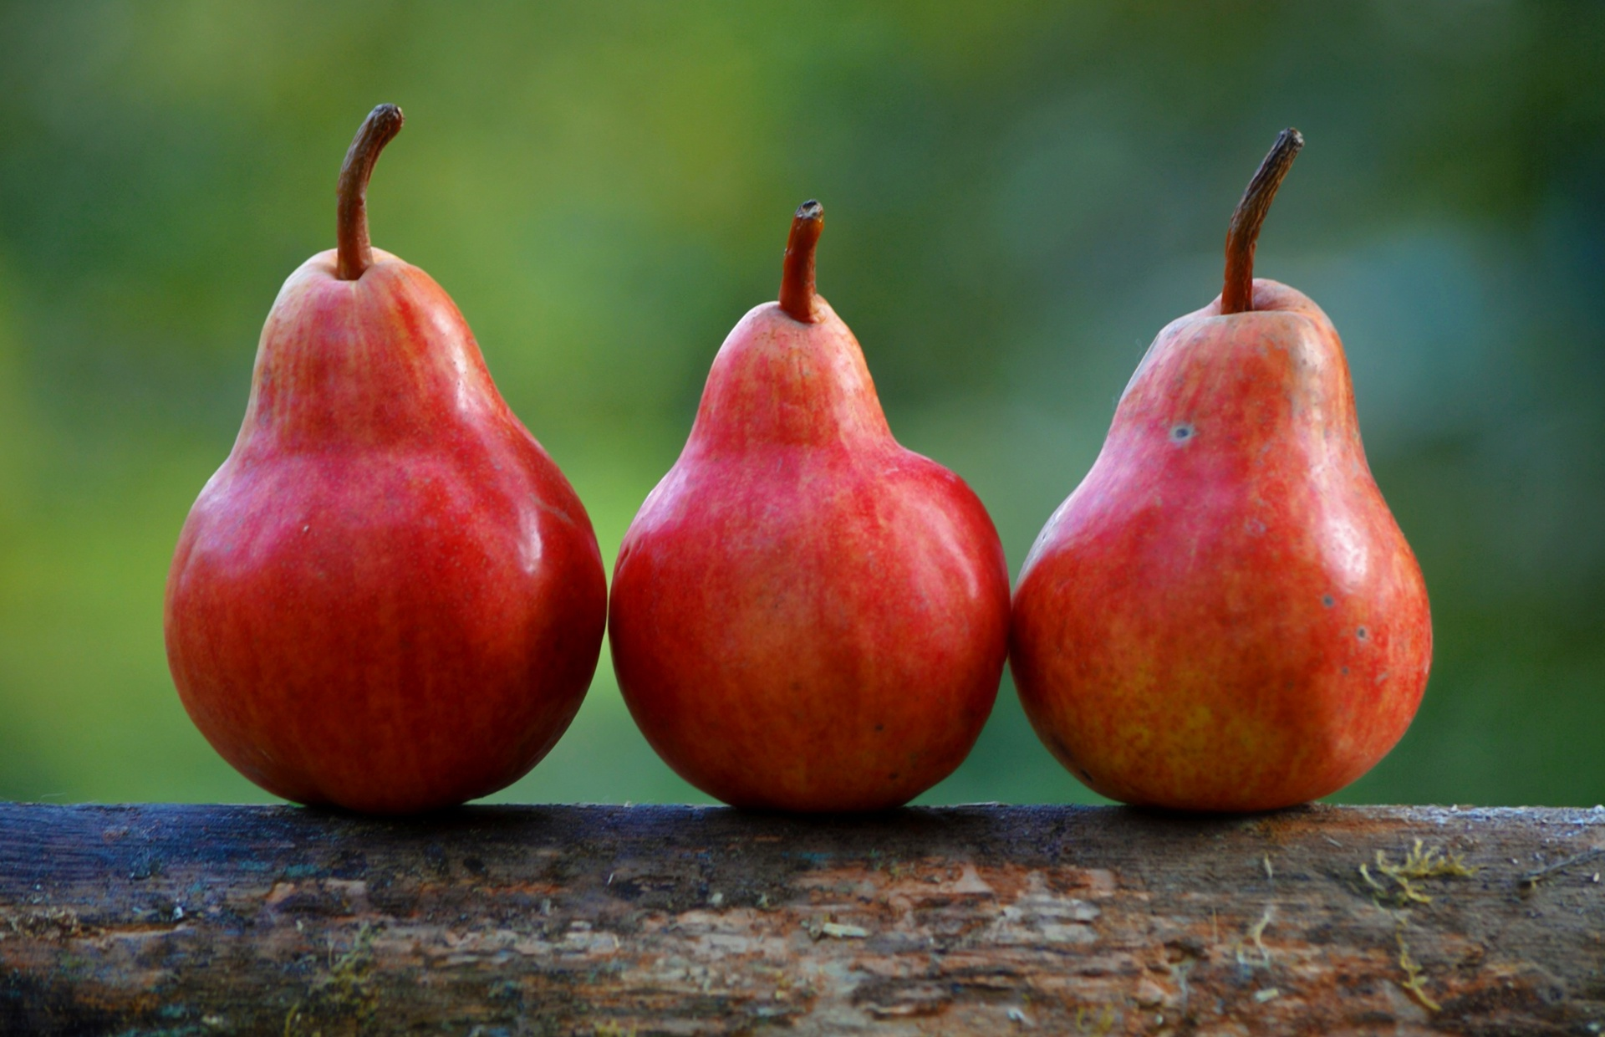
Healthy Bodies – Healthy Minds
MENU
Nov11-Nov15, 2024
A rainbow of colorful nutritious food helps us grow strong and healthy!

 | Monday 11 | Tuesday 12 | Wednesday 13 | Thursday 14 | Friday 15
Breakfast | Oatmeal(wgr): ¼ cup  Pears: ½ cup  Milk: ¾ cup | Life Cereal (wgr): ½ ea.  Honeydew: ½ cup  Milk: ¾ cup | Corn Flakes: ½ cup  Apples: ½ cup  Milk: ¾ cup | Mini Wheats (wgr): ½ cup  Oranges: ½ cup  Milk: ¾ cup | W.W. Eng. Muffin(wgr): ½ each  Watermelon: ½ cup  Milk: ¾ cup
Lunch | Navy Bean Soup  Navy Beans Soup:1cup  Dinner Roll: 1each  Baby Cut Carrots: ¼ cup  Oranges: ¼ cup  Milk: ¾ cup | Cheese Sandwiches  Sliced Cheese:1 ½ oz  W.W. Bread(wgr): 1slice  Sliced Cucumber: ¼ cup  Banana: ¼ cup  Milk: ¾ cup | Red Beans &Rice  Red Beans(W/sauce): 3/8cup  Brown Rice(wgr): ¼ cup  Green Beans: ¼ cup  Pears: ¼ cup  Milk: ¾ cup | Vermicelli Noodle  Rice Noodle(W/sauce): ¼ cup.  Mix Vegetable: ¼ cup.  Sliced Cheese:1 ½ oz  Cantaloup: ¼ cup  Milk: ¾ cup | Chicken Taco  Seasonings Chicken:1 ½ oz.  Corn Tortilla:1slice  Mix Cheese: ½ oz  Diced Tomatoes: ¼ cup  Apples: ¼ cup  Milk: ¾ cup
Snack | Raisin Bread: ½ slice  Applesauce: ½ cup | Yogurt: ¼ cup  Pineapple: ½ cup | Sliced Cucumber: ½ cup  Feta Dip:1tbsp  W.W. Crackers: ½ oz | Banana Muffins:1each  Banana: ½ cup  Milk: ½ cup | Fish Crackers: ½ oz.  Fruit Medley: ½ cup

§Alternative items for milk/ dairy (w/ med. documentation): Soy milk •Alternative items for meat: Beans, tofu, &/or cheese
*Alternative items for gluten & soy will be served with medical authorization only. W.W. = Whole Wheat

Milk: Whole milk is served to children aged 12 mos. to 23 mos. (wgr) = Whole Grain
Low Fat (1% fat) milk is served to children 2 years old through school-age.

“Fruit Medley” = Any fresh fruit available at the site.

