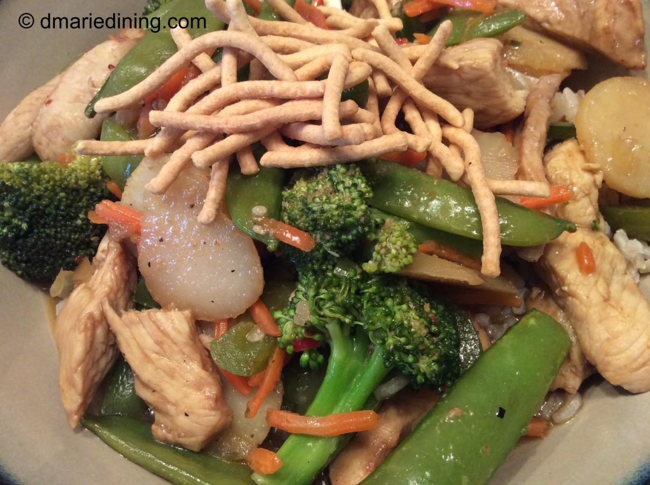
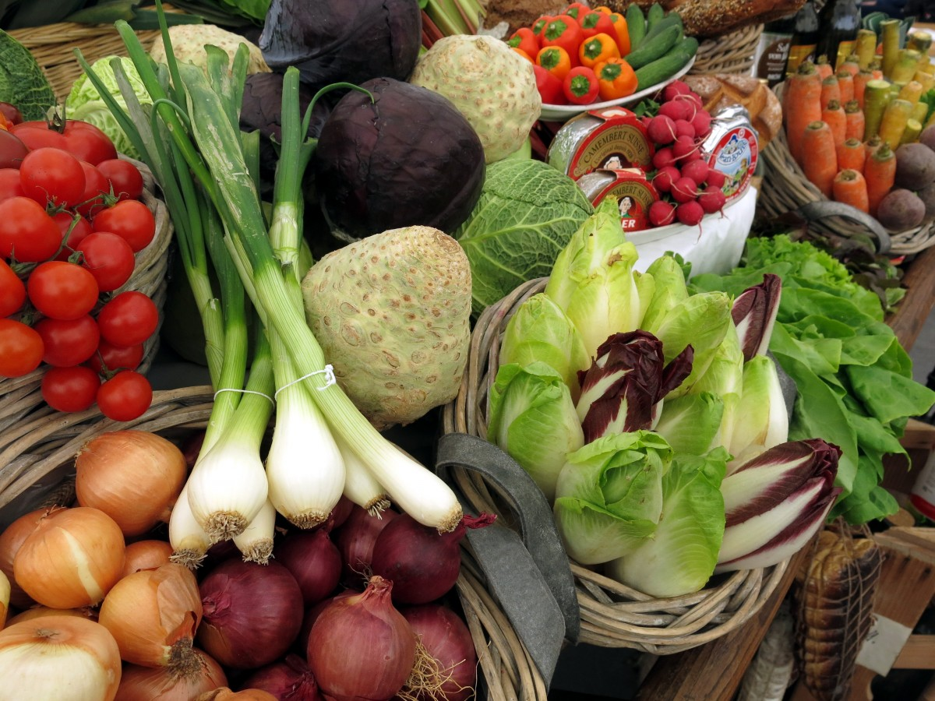
Healthy Bodies – Healthy Minds
MENU
March 31-April 04, 2025
A rainbow of colorful nutritious food helps us grow strong and healthy!

 | Monday 31 | Tuesday 01 | Wednesday 02 | Thursday 03 | Friday 04
Breakfast | Rice Pocket: ½ cup  Oranges: ½ cup  Milk: ¾ cup | Life Cereal(wgr): ½ cup.  Honeydew: ½ cup  Milk: ¾ cup | Cream of Wheats: ¼ cup  Pineapple: ½ cup  Milk: ¾ cup | Cheerio(wgr): ½ cup  Pears: ½ cup  Milk: ¾ cup | C C F C Closed  
Lunch | Cabbage-Rice Soup  Cabbage-Rice Soup:1 cup  Sliced Cheese:1 ½ oz  Baby Cut Carrots: ¼ cup.  Pears: ¼ cup  Milk: ¾ cup | Pasta with Squash  Bowtie Pasta(w/sauce): ¼ cup  Edamame:3/8Cup  Sliced Cucumber: ¼ cup  Banana: ¼ cup  Milk: ¾ cup | Bean Burritos  Black Bean(w/sauce): ¼ cup  Corn tortilla:1each  Shredded Cheeses: ½ oz  Diced tomatoes: ¼ cup  Apples: ¼ cup  Milk: ¾ cup | Chicken Broccoli Stir-Fry  Baked Chicken:1 ½ oz.  Egg Noodle: ¼ cup  Broccoli: ¼ cup  Banana: ¼ cup  Milk: ¾ cup
Snack | Brown Rice Cake (wgr):1each  Fruit Compote:1tbsp  Milk: ½ cup | Homemade Pita Chip: ½ oz  Hummus:1/8Cup | Celery Sticks: ½ cup  Veggie Dip:1tbsp  W.W. Crackers(wgr): ½ oz | Greek Yogurt: ¼ cup  Fruit Medley: ½ cup

§Alternative items for milk/ dairy (w/ med. documentation): Soy milk •Alternative items for meat: Beans, tofu, &/or cheese
*Alternative items for gluten & soy will be served with medical authorization only. W.W. = Whole Wheat

Milk: Whole milk is served to children aged 12 mos. to 23 mos. (wgr) = Whole Grain
Low Fat (1% fat) milk is served to children 2 years old through school-age.

“Fruit Medley” = Any fresh fruit available at the site.

