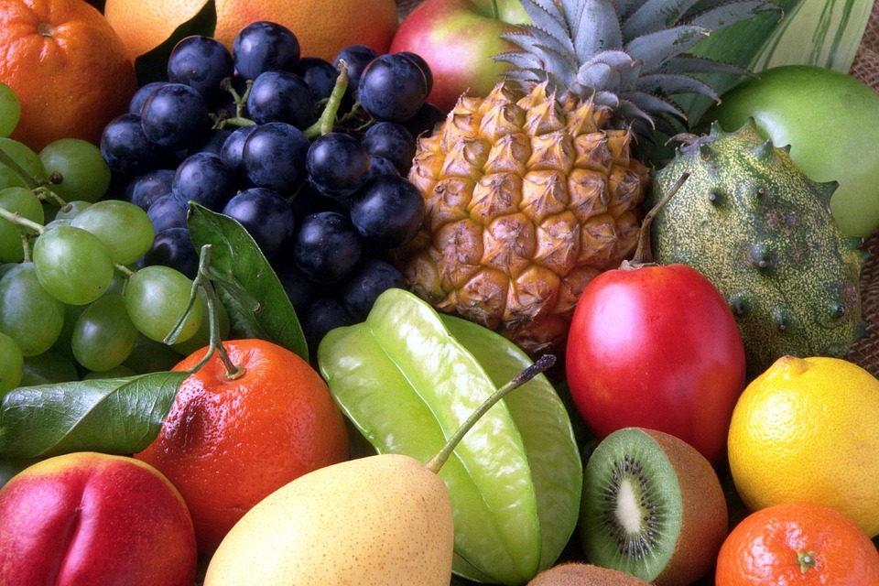
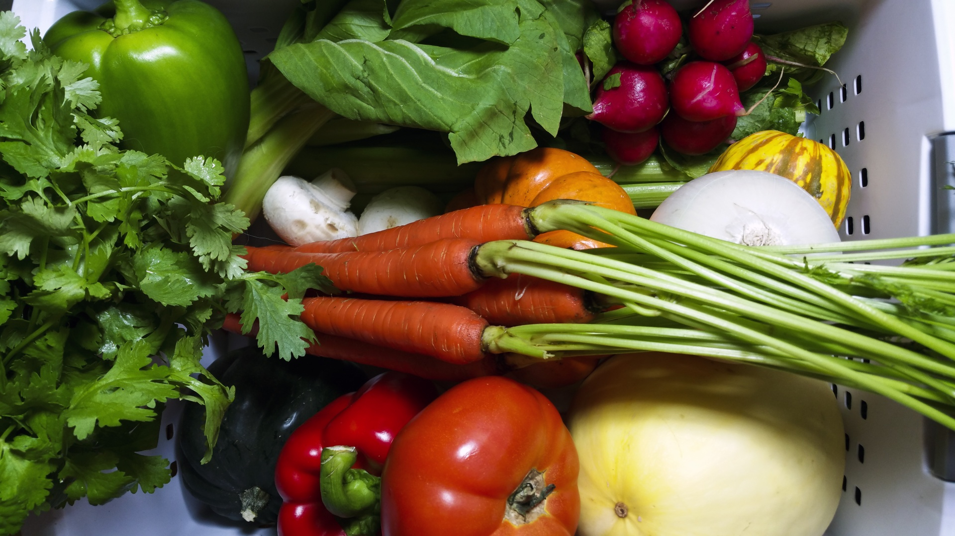
Healthy Bodies – Healthy Minds
MENU
Nov 04-Nov 08, 2024
A rainbow of colorful nutritious food helps us grow strong and healthy!

 | Monday 04 | Tuesday 05 | Wednesday 06 | Thursday 07 | Friday 08
Breakfast | Mini Wheats(wgr): ½ cup  Oranges: ½ cup  Milk: ¾ cup | Cheerios(wgr): ½ cup  Watermelon: ½ cup  Milk: ¾ cup | Rice Pockets: ½ cup  Pears: ½ cup  Milk: ¾ cup | Life cereal(wgr): ½ cup  Apples: ½ cup  Milk: ¾ cup | Corn Flakes: ½ cup  Banana: ½ cup  Milk: ¾ cup
Lunch | Minestrone Soup  Minestrone Soup: 1 Cup.  W.W. Crackers (wgr): ½ oz.  Green Bell Pepper: ¼ cup.  Cheese Sticks: 1 ½ oz  Apples: ¼ cup  Milk: ¾ cup | Bagels & Cream Cheese  Mini Begel :1 each  Cream Cheese:1 tbsp.  Edamame; 3/8 cup  Sliced Cucumber: ¼ cup  Banana: ¼ cup  Milk: ¾ cup | Spaghetti Marinara  Spaghetti(w/marinara): ¼ cup  Mix Vegetable: ¼ cup  Sliced Cheese:1 ½ oz  Oranges: ¼ cup  Milk: ¾ cup | Coconut-Ginger Chickpeas  Chickpeas:3/8cup  W.W. Bread(wgr):1slice  Baby Cut Carrots: ¼ cup  Honeydew: ¼ cup  Milk: ¾ cup | Chicken Broccoli Stir-Fry  Baked Chicken: 1 ½ oz.  Brown Rice(wgr): ¼ cup.  Broccoli: ¼ cup.  Pears: ¼ cup  Milk: ¾ cup
Snack | Rice Cake:1each  Fruit Compote:1tbsp  Milk: ½ cup | Cottage Cheese: ¼ cup  Strawberries: ½ cup | W.W. Pita. Bread(wgr): ½ slice  Pinto Bean Dip: 1/8 cup | . Yogurt: ¼ cup  Pineapple: ½ cup. | Raisin Bread: ½ slice  Fruit Medley: ½ cup

§Alternative items for milk/ dairy (w/ med. documentation): Soy milk •Alternative items for meat: Beans, tofu, &/or cheese
*Alternative items for gluten & soy will be served with medical authorization only. W.W. = Whole Wheat

Milk: Whole milk is served to children aged 12 mos. to 23 mos. (wgr) = Whole Grain
Low Fat (1% fat) milk is served to children 2 years old through school-age.

“Fruit Medley” = Any fresh fruit available at the site.

