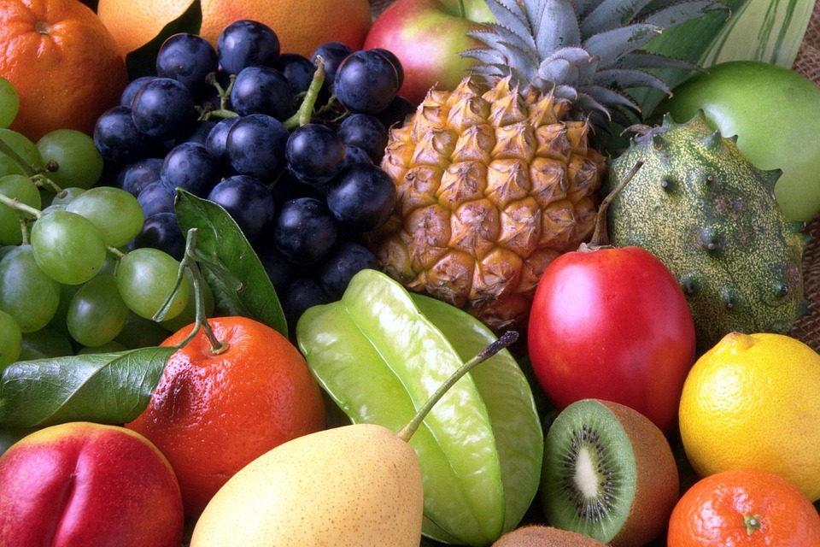
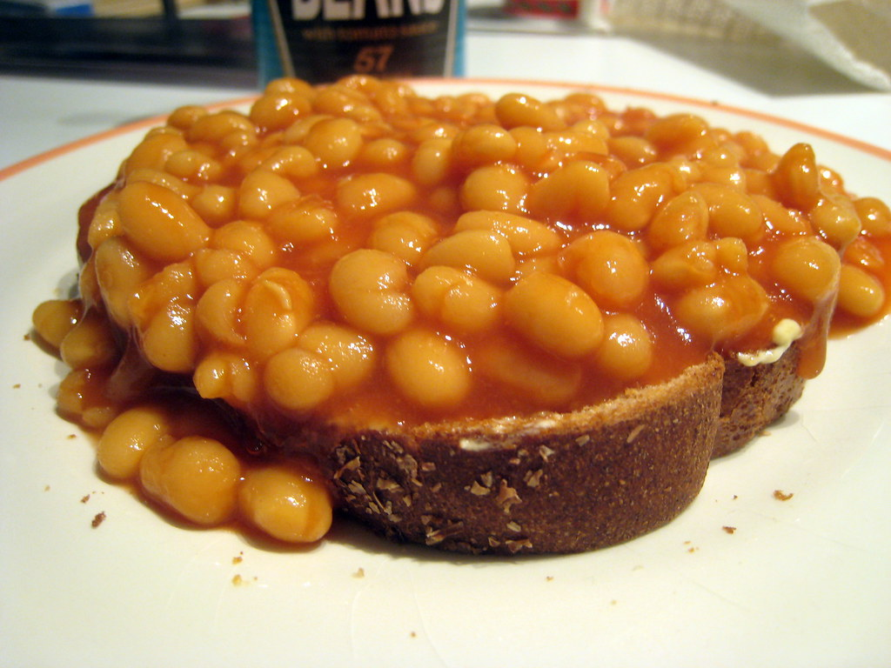
Healthy Bodies – Healthy Minds
MENU
April07-April11, 2025
A rainbow of colorful nutritious food helps us grow strong and healthy!

 | Monday 07 | Tuesday 08 | Wednesday 09 | Thursday 10 | Friday 11
Breakfast | Oatmeal(wgr): ¼ cup  Apples: ½ cup  Milk: ¾ cup | Corn Flakes: ½ cup  Orange: ½ cup  Milk: ¾ cup | Life Cereal(wgr): ½cup  Watermelon: ½ cup  Milk: ¾ cup | Kix Cereal (wgr): ½cup  Pears: ½ cup  Milk: ¾ cup | Cheerios(wgr): ½ cup  Watermelon: ½ cup  Milk: ¾ cup
Lunch | Minestrone Soup  Minestrone Soup:1cup  W.W. Crackers(wgr): ½ oz  Baby Cut Carrots: ¼ cup  Pears: ¼ cup  Milk: ¾ cup | B.B.Q Baked Beans  Mix Beans:3/8cup  W.W. Pita. Bread(wgr): ½ slice  Cauliflower: ¼ cup  Banana: ¼ cup  Milk: ¾ cup | Veggie Fried Rice Noodle  Rice noodle(w/sauce): ¼ cup  Baby Bok Choy: ¼ cup  Lima Beans:3/8cup  Apples: ¼ cup  Milk: ½ cup | Tuna Salad Sandwiches  Tuna(in/salad):1 ½ oz  W.W. Bread:1slice  Sliced Tomatoes: ¼ cup  Cantaloupe: ¼ cup  Milk: ½ cup | Baked Tilapia  Baked Tilapia(w/sauce):1 ½ oz.  Brown Rice(wgr): ¼ cup.  Mix Vegetable: ¼ cup  Banana: ¼ cup  Milk: ¾ cup
Snack | Raisin Bread: ½ slice  Applesauce: ½ cup | Cottage Cheese: ¼ cup  Honeydew: ½ cup | Sliced Cucumber: ½ cup  Italian Dressing: 1tbsp  Pretzels: ½ oz | Sunflower seed butter Cookies:1ea  Milk: ½ cup | Sliced Cheese:1 oz  Fruit Medley: ½ cup

§Alternative items for milk/ dairy (w/ med. documentation): Soy milk •Alternative items for meat: Beans, tofu, &/or cheese
*Alternative items for gluten & soy will be served with medical authorization only. W.W. = Whole Wheat

Milk: Whole milk is served to children aged 12 mos. to 23 mos. (wgr) = Whole Grain
Low Fat (1% fat) milk is served to children 2 years old through school-age.

“Fruit Medley” = Any fresh fruit available at the site.

