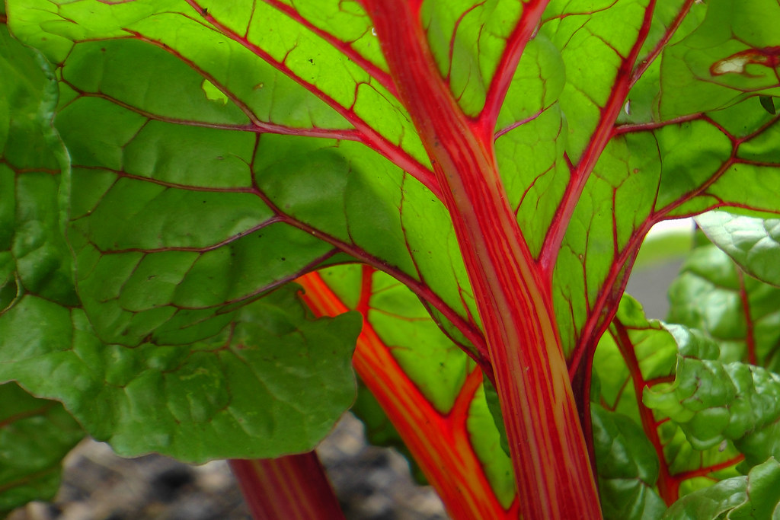
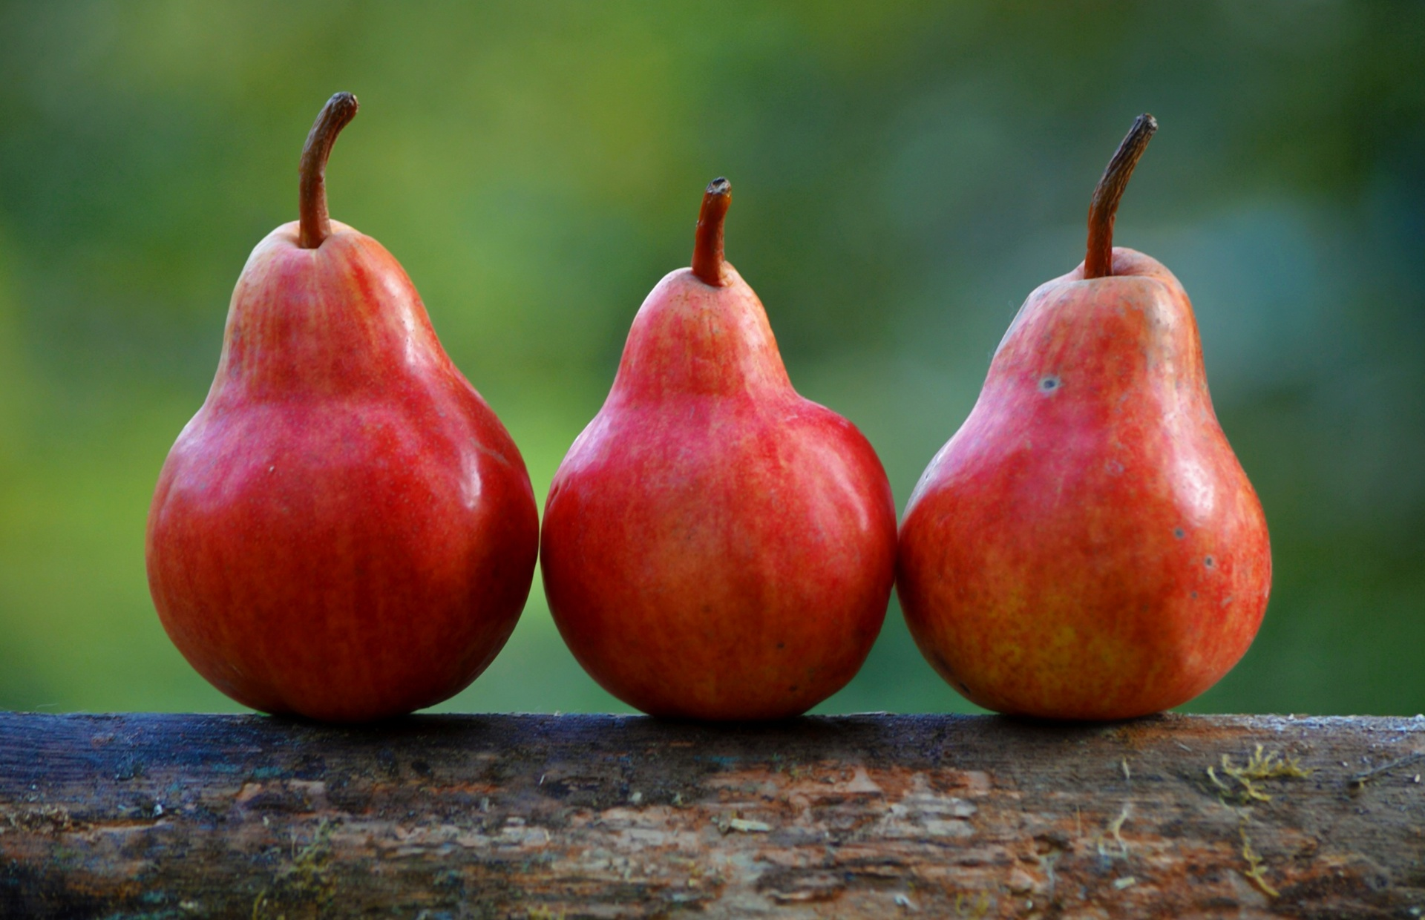
Healthy Bodies – Healthy Minds
MENU
Oct28-Nove 01, 2024
A rainbow of colorful nutritious food helps us grow strong and healthy!

 | Monday 28 | Tuesday 29 | Wednesday 30 | Thursday 31 | Friday 01
Breakfast | Corn Flakes: ½ cup  Oranges: ½ cup  Milk: ¾ cup | Life Cereal(wgr): ½ cup.  Honeydew: ½ cup  Milk: ¾ cup | Mini Wheats(wgr): ½ cup  Pineapple: ½ cup  Milk: ¾ cup | Cheerio(wgr): ½ cup  Pears: ½ cup  Milk: ¾ cup | W.W. Eng Muffin(wgr): ½ slice  Cantaloupe: ½ cup  Milk: ¾ cup
Lunch | Cheese Sandwiches  Sliced Cheese: 1 ½ oz.  Cole Slaw: ¼ cup  W.W. Bread(wgr): 1slice  Apples: ¼ cup  Milk: ¾ cup | Baked Pasta in Tomato Sauce  Baked Pasta: ¼ cup.  Garbanzo Beans: 3/8 cup.  Sliced Green Bell Pepper: ¼ cup.  Banana: ¼ cup  Milk: ¾ cup | Cabbage-Vegetable Soup  Cabbage-Veggie Soup:1 cup  Cheese Sticks:1 ½ oz  Dinner Roll: 1each.  Baby Cut Carrots: ¼ cup.  Orange: ¼ cup  Milk: ¾ cup | Bean Burritos  Black Beans: ¼ cup  Shredded Cheese: ½ cup  Diced Tomatoes: ½ cup  Watermelon: ¼ cup  Milk: ¾ cup | Chicken Broccoli Stir-Fry  Chicken Bread:1 ½ oz.  Brown Rice(wgr): ¼ cup  Broccoli: ¼ cup  Banana: ¼ cup  Milk: ¾ cup
Snack | Corn Tortilla Chip: ½ oz  Hummus: 1/8 cup | Rice Cake:1each  Fruit Compote:1tbsp  Milk: ½ cup | Yogurt: ¼ cup  Homemade Granola:1tbsp.  Strawberries: ½ cup | Celery Sticks: ½ cup  Veggie Dip:1tbsp  W.W. Crackers(wgr): ½ oz | Fish Crackers: ½ oz  Fruit Medley: ½ cup

§Alternative items for milk/ dairy (w/ med. documentation): Soy milk •Alternative items for meat: Beans, tofu, &/or cheese
*Alternative items for gluten & soy will be served with medical authorization only. W.W. = Whole Wheat

Milk: Whole milk is served to children aged 12 mos. to 23 mos. (wgr) = Whole Grain
Low Fat (1% fat) milk is served to children 2 years old through school-age.

“Fruit Medley” = Any fresh fruit available at the site.

