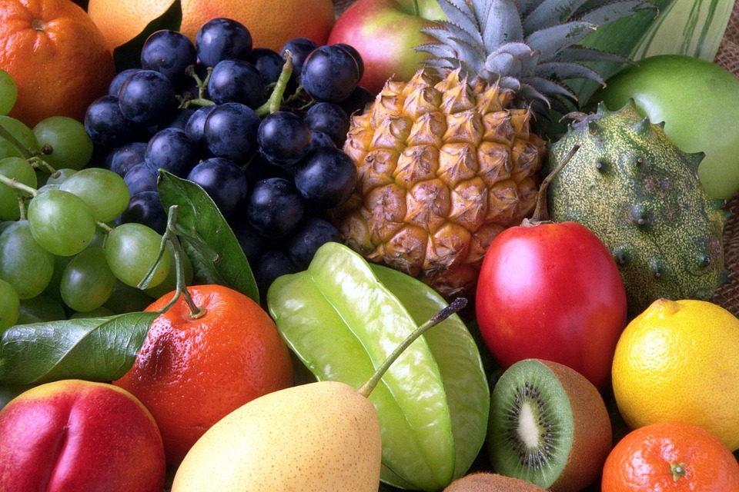
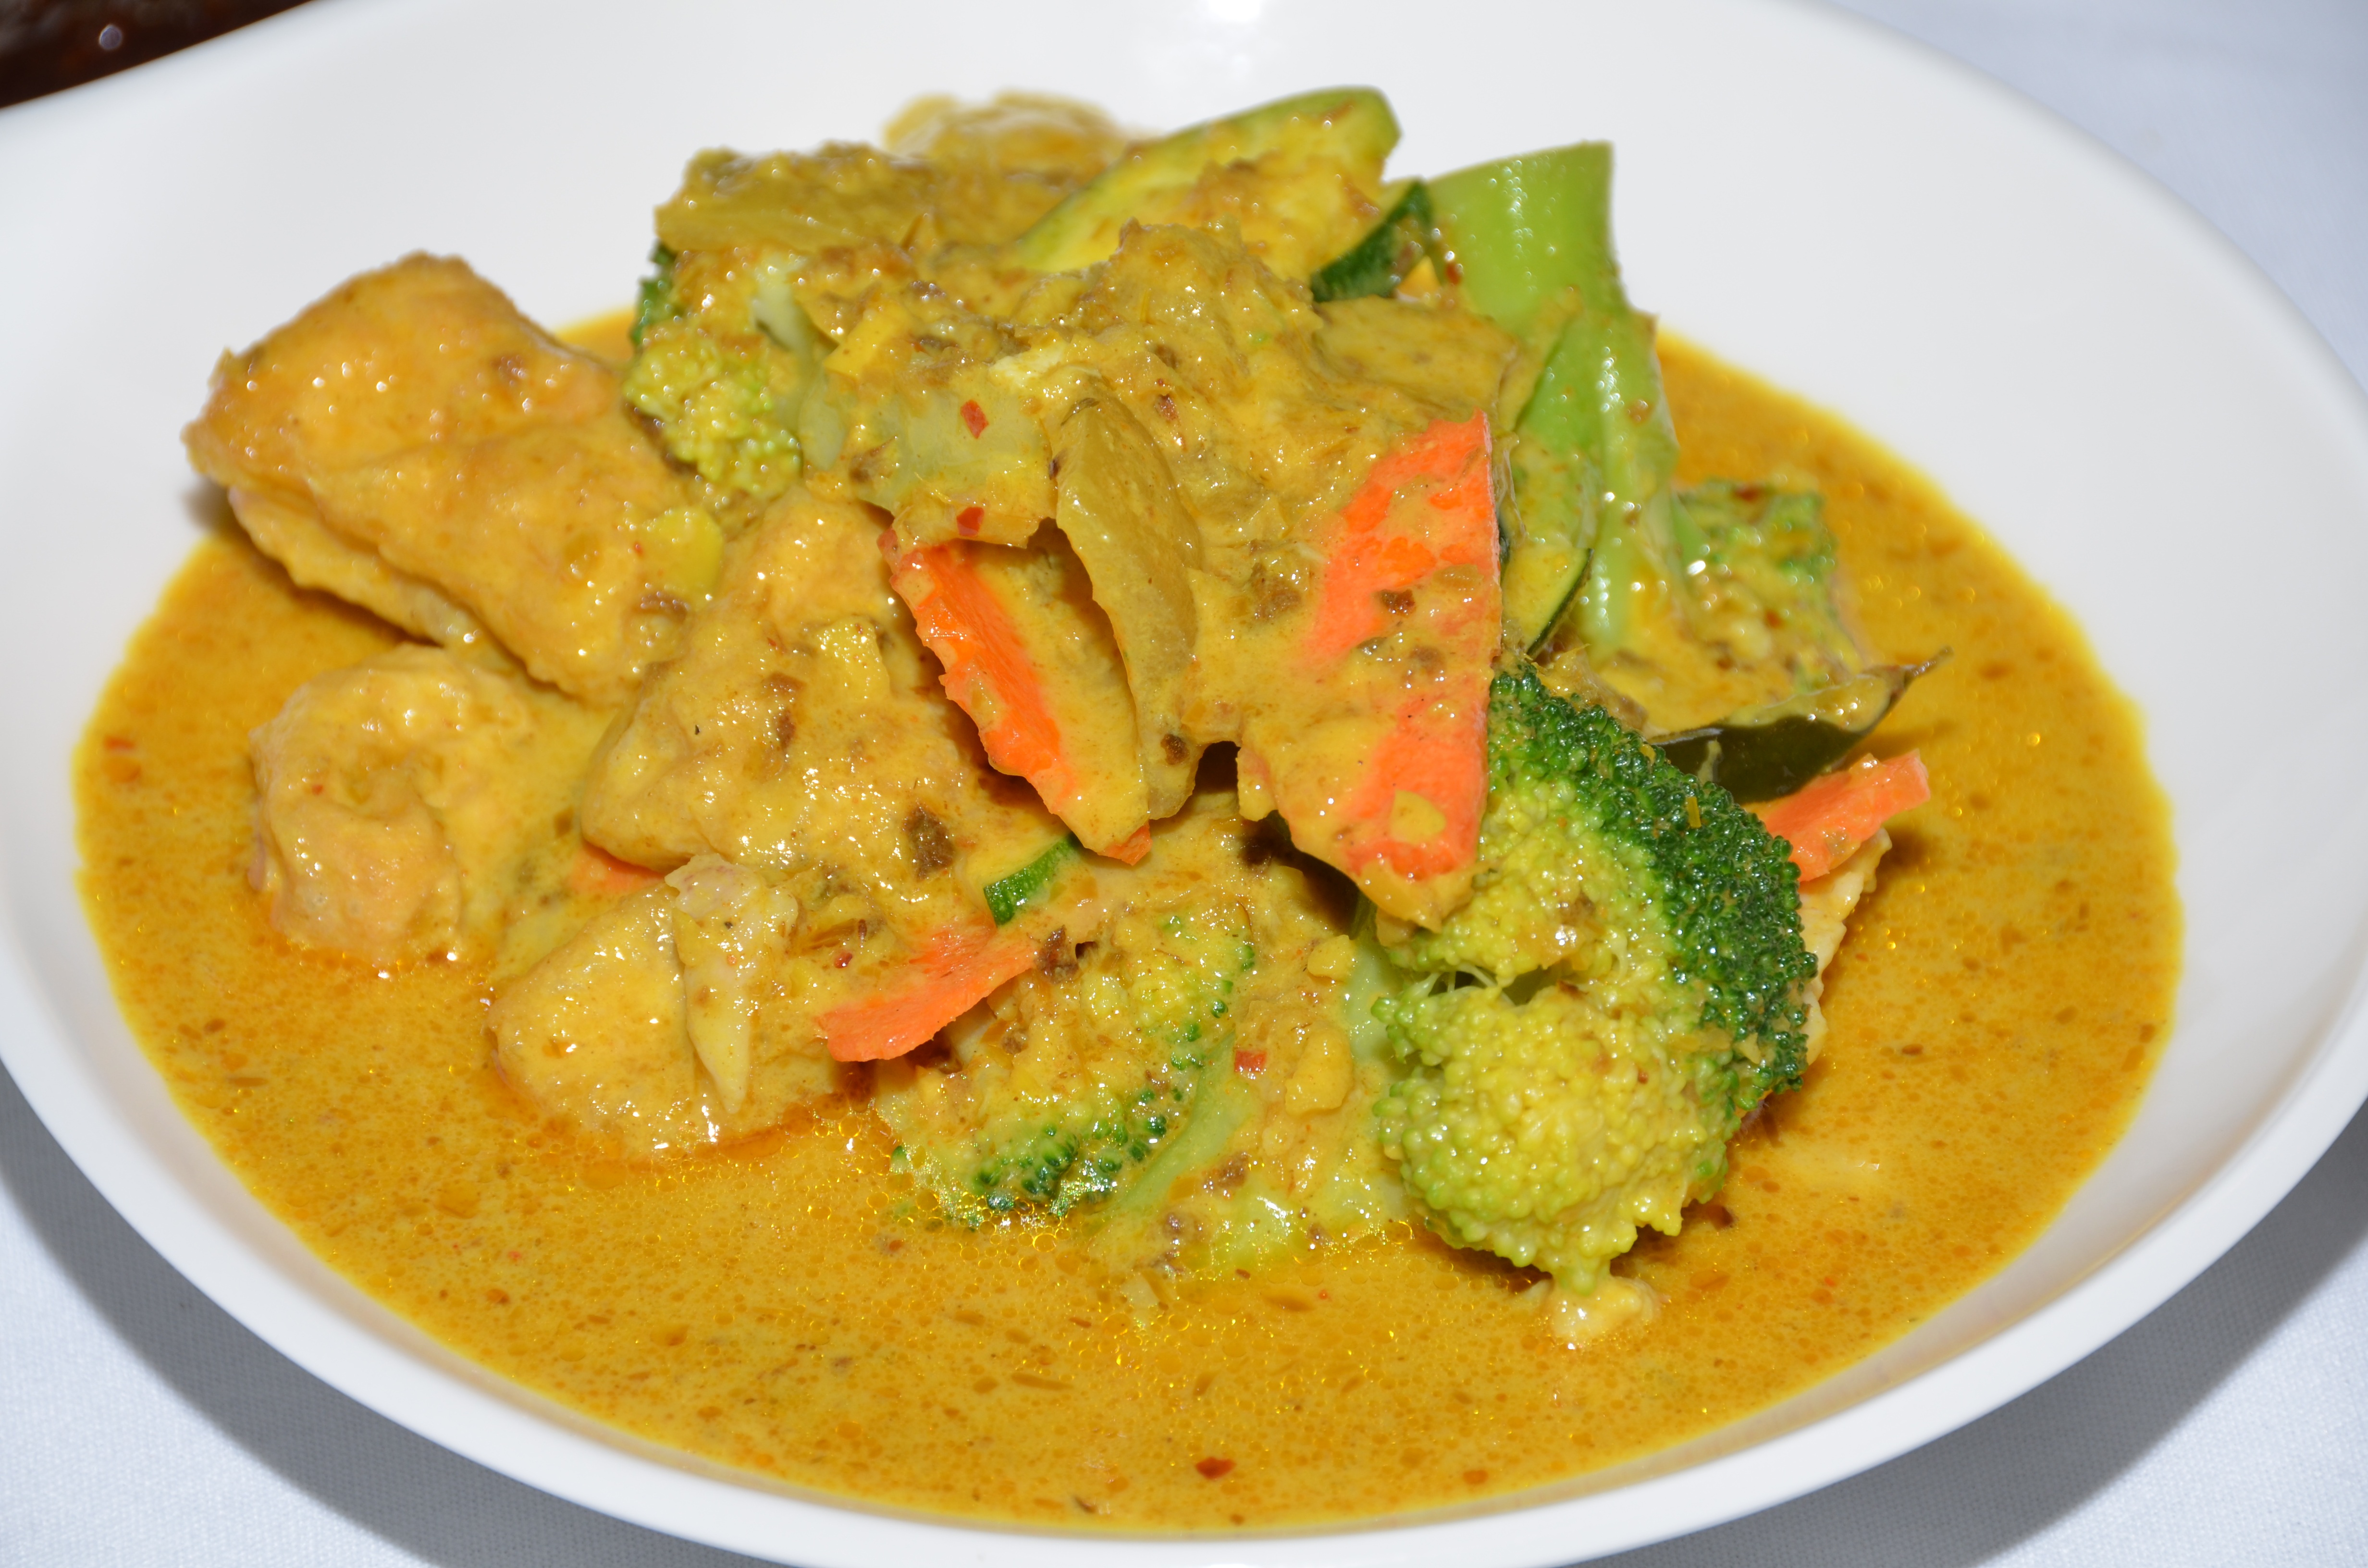
Healthy Bodies – Healthy Minds
MENU
04/14-04/ 18- 2025
A rainbow of colorful nutritious food helps us grow strong and healthy!

 | Monday 14 | Tuesday 15 | Wednesday 16 | Thursday 17 | Friday 18
Breakfast | Cheerios(wgr): ½ cup  Oranges: ½ cup  Milk: ¾ cup | Cream of Wheat: ¼ cup  Honeydew: ½ cup  Milk: ¾ cup | Kix Cereal(wgr): ½ cup  Apples: ½ cup  Milk: ¾ cup | Rice Pockets: ½ cup  Pears: ½ cup  Milk: ¾ cup |  | W.W. Eng. Muffin(wgr): ½ ea  Banana: ½ cup  Milk: ¾ cup
Lunch | Fettuccine Alfredo  Fettuccine (Alfredo sauce): ¼ cup  Cannellini Bean: ¼ cup  Baby Cut Carrots: ¼ cup  Pears: ¼ cup  Milk: ¾ cup | Cheese Sandwich  Sliced Cheese: 1 ½ oz  W.W. Bread(wgr): 1 slice  Coleslaw: ¼ cup.  Banana: ¼ cup  Milk: ¾ cup | Potato-leek Soup  Potato-leek soup:1cup  W.W. Pita Bread (wgr): ½slice  Baby Cut Carrots: ¼ cup  Slice Cheese: 1 ½ oz  Strawberries: ¼ cup  Milk: ¾ cup | Bean Burritos  Black Bean(w/sauce): ¼ cup  Corn Tortilla:1each  Shredded Cheese: ½ oz  Diced Tomatoes: ¼ cup  Oranges: ¼ cup  Milk: ¾ cup |  | Coconut Curry Chicken  Baked Chicken(w/sauce):1 ½ oz  Cauliflower: ¼ cup  Brown Rice(wgr): ¼ cup  Apples: ¼ cup  Milk: ¾ cup
Snack | Sunflower Butter: 1tbsp.  Slices Apple: ½ cup | Corn Tortilla Chip: ½ oz  Pinto Beans Dip:1/8cup | Yogurt: ¼ cup  Cantaloupe : ½ cup | Fresh mix veggie: ½ cup  Ranch Dip:1tbsp  W.W. Crackers(wgr): ½ oz |  | Gold Fish Crackers: ½ oz  Fruit Medley: ½ cup

§Alternative items for milk/ dairy (w/ med. documentation): Soy milk •Alternative items for meat: Beans, tofu, &/or cheese
*Alternative items for gluten & soy will be served with medical authorization only. W.W. = Whole Wheat

Milk: Whole milk is served to children aged 12 mos. to 23 mos. (wgr) = Whole Grain
Low Fat (1% fat) milk is served to children 2 years old through school-age.

“Fruit Medley” = Any fresh fruit available at the site.

